HOLY TRINITY ANGLICAN CHURCH

December 25th, 2024 10:30AM | The Feast of the Incarnation

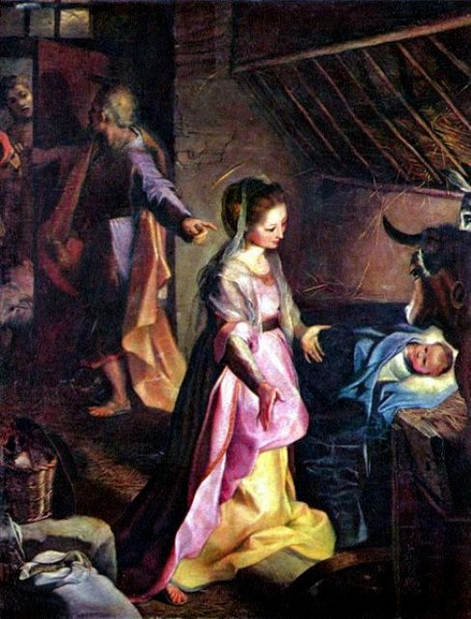
The Birth of Christ, Federico Barocci, 1597

I bring you good news of great joy which will come to all the people;
for to you is born this day a Saviour, Christ the Lord.
Luke 2:10-11

THE GATHERING OF THE COMMUNITY

Prelude

(Please stand)
Processional Hymn #121: O Little Town of Bethlehem

Apostolic Greeting
(Please Stand)
The grace of our Lord Jesus Christ, and the love of God, and the fellowship of the Holy Spirit, be with you all.
All: And also with you.

Gloria: Angels We Have Heard on High
1. Angels we have heard on high,  Sweetly singing o’er the plains,  And the mountains in reply,  Echoing their joyous strains  Refrain: Gloria, in excelsis Deo! Gloria, in excelsis Deo! | 2. Come to Bethlehem and see,  Christ whose birth the angels sing;  Come, adore on bended knee,  Christ the Lord, the newborn King.  Refrain

Collect of the Day: O God, you make us glad by the yearly festival of the birth of your only Son Jesus Christ: Grant that we, who joyfully receive him as our Redeemer, may with sure confidence behold him when he comes to be our Judge; who lives and reigns with you and the Holy Spirit, one God, now and for ever. Amen.

THE PROCLAMATION OF THE WORD

Isaiah 9:2-7. If we are looking for a source for some of Jesus’ titles, we need look no further than this passage. The original prophecy related to the birth of an heir to the throne of David, sometime around 700 BCE. We read it today in terms of the birth of the eternal heir to David’s throne.

A reading from Isaiah (9:2-7)
The people who walked in darkness have seen a great light; those who lived in a land of deep darkness—on them light has shined. You have multiplied the nation, you have increased its joy;
they rejoice before you as with joy at the harvest, as people exult when dividing plunder. For the yoke of their burden, and the bar across their shoulders, the rod of their oppressor, you have broken as on the day of Midian. For all the boots of the tramping warriors and all the garments rolled in blood shall be burned as fuel for the fire. For a child has been born for us, a son given to us; authority rests upon his shoulders; and he is named Wonderful Counsellor, Mighty God, Everlasting Father, Prince of Peace. His authority shall grow continually, and there shall be endless peace for the throne of David and his kingdom. He will establish and uphold it with justice and with righteousness from this time onwards and for evermore. The zeal of the Lord of hosts will do this.
The Word of the Lord
All: Thanks be to God.

Psalm 96. A hymn calling the people to proclaim the greatness of God, probably originally used in the fall harvest festival, which celebrated God’s re-creation of the earth for the coming year. As we celebrate the birth of Christ, we proclaim that heaven and earth are joined together: God’s eternal re-creation.

Psalm 96 (said)
Sing to the Lord a new song; sing to the Lord, all the whole earth.
Sing to the Lord and bless his name; proclaim the good news of his salvation from day to day.
Declare his glory among the nations and his wonders among all peoples.
For great is the Lord and greatly to be praised; he is more to be feared that all gods.
As for all the gods of the nations, they are but idols; but it is the Lord who made the heavens.
Oh, the majesty and magnificence of his presence! Oh, the power and the splendour of his sanctuary!
Ascribe to the Lord, you families of the peoples; ascribe to the Lord honour and power.
Ascribe to the Lord the honour due his name; bring offerings and come into his courts.
Worship the Lord in the beauty of holiness; let the whole earth tremble before him.
Tell it out among the nations: “The Lord is king! He has made the world so firm that it cannot be moved; he will judge the peoples with equity.”
Let the heavens rejoice, and let the earth be glad; let the sea thunder and all that is in it; let the field be joyful and all that is therein.
Then shall all the trees of the wood shout for joy before the Lord when he comes, when he comes to judge the earth.
He will judge the world with righteousness and the peoples with his truth.

Titus 2:11-14. Concerned mainly with institutional matters, the pastoral epistles (I & II Timothy & Titus) also deal with some serious theological matters. This short passage links the first coming of Christ to his second, reminding us that the Christmas story has cosmic consequences.

A reading from Titus (2:11-14)
For the grace of God has appeared, bringing salvation to all, training us to renounce impiety and worldly passions, and in the present age to live lives that are self-controlled, upright, and godly, while we wait for the blessed hope and the manifestation of the glory of our great God and Saviour, Jesus Christ. He it is who gave himself for us that he might redeem us from all iniquity and purify for himself a people of his own who are zealous for good deeds.
The Word of the Lord
All: Thanks be to God.

Gospel Acclamation: 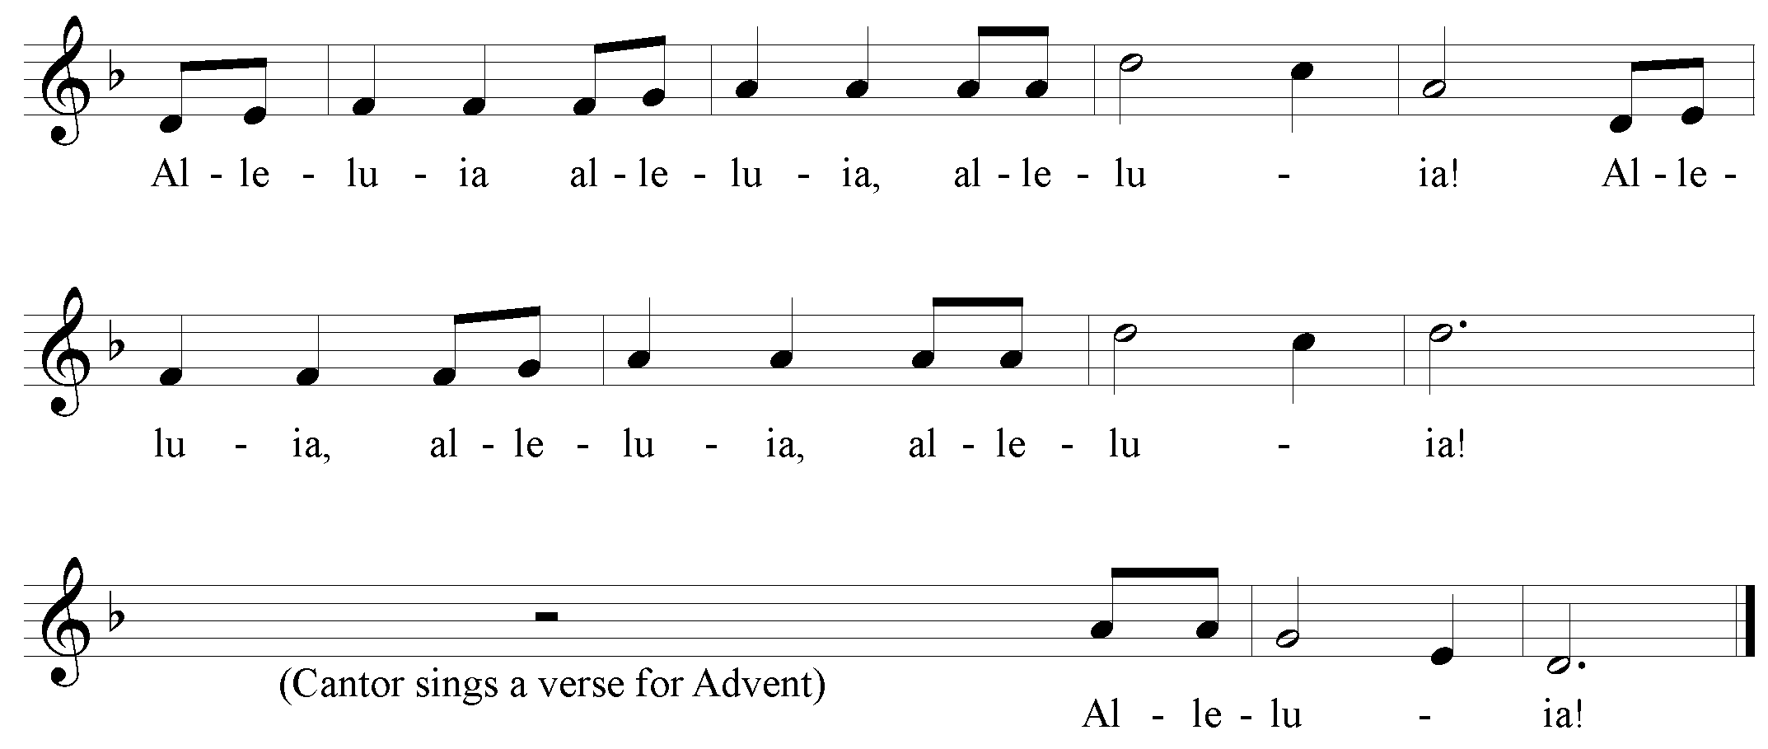
Gospel Reading
The Lord be with you.
All: And also with you.
The Holy Gospel of our Lord Jesus Christ according to Luke (2:1-20).
All: 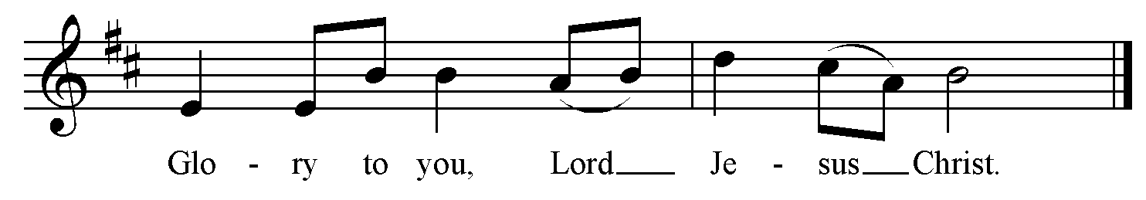
In the beginning was the Word, and the Word was with God, and the Word was God. He was in the beginning with God. All things came into being through him, and without him not one thing came into being. What has come into being in him was life, and the life was the light of all people. The light shines in the darkness, and the darkness did not overcome it. There was a man sent from God, whose name was John. He came as a witness to testify to the light, so that all might believe through him. He himself was not the light, but he came to testify to the light. The true light, which enlightens everyone, was coming into the world. He was in the world, and the world came into being through him; yet the world did not know him. He came to what was his own, and his own people did not accept him. But to all who received him, who believed in his name, he gave power to become children of God, who were born, not of blood or of the will of the flesh or of the will of man, but of God. And the Word became flesh and lived among us, and we have seen his glory, the glory as of a father's only son, full of grace and truth.

The Gospel of Christ.
All: 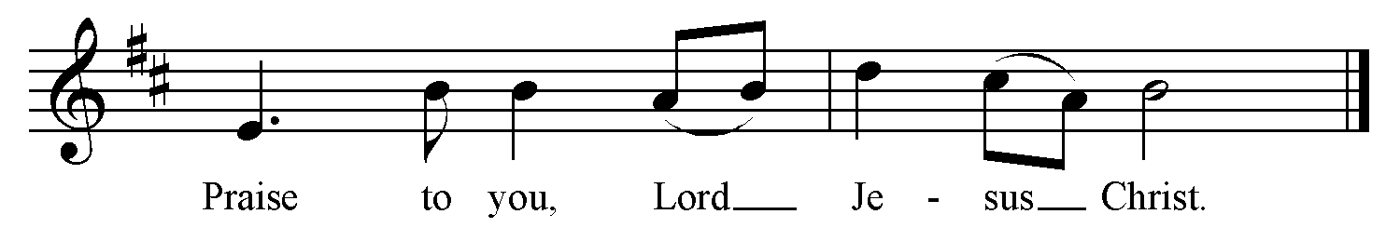

Gospel Acclamation:
The Sermon: The Rev. Rob Key

The Apostles’ Creed:
Let us confess the faith of our baptism as we say,
I believe in God, the Father almighty, creator of heaven and earth.
I believe in Jesus Christ, his only Son, our Lord. He was conceived by the power of the Holy Spirit and born of the Virgin Mary. He suffered under Pontius Pilate, was crucified, died, and was buried. He descended to the dead. On the third day he rose again. He ascended into heaven, and is seated at the right hand of the Father. He will come again to judge the living and the dead.

The Prayers of the People
Lord in your mercy…
All: Hear our prayer.

Confession and Absolution
The sun of righteousness has dawned with healing in his wings. Let us come to the light and confess our sins. Most merciful God,
All: We confess that we have sinned against you in thought, word, and deed, by what we have done, and by what we have left undone. We have not loved you with our whole heart; we have not loved our neighbour as ourselves. We are truly sorry and we humbly repent. For the sake of your Son Jesus Christ, have mercy on us and forgive us, that we may delight in your will, and walk in your ways, to the glory of your name. Amen.
May God who loved the world so much that he sent his Son to be our Saviour forgive us our sins and make us holy to serve him in the world, through Jesus Christ our Lord. Amen.

The Peace
Glory to God in the highest heaven, and on earth peace to all in whom God delights.
The peace of the Lord be always with you.
All: And also with you.

THE CELEBRATION OF THE EUCHARIST

Offertory Hymn #145: Good King Wenceslas

Prayer over the Gifts: God of peace, your Son Jesus Christ has reconciled us to you. May all we offer you today renew us as members of your household. We ask this in his name. Amen.

Eucharistic Prayer 2
The Lord be with you.
All: And also with you.
Lift up your hearts.
All: We lift them to the Lord.
Let us give thanks to the Lord our God.
All: It is right to give our thanks and praise.
We give you thanks and praise, almighty God, through your beloved Son, Jesus Christ, our Saviour and Redeemer. He is your living Word, through whom you have created all things.

By the power of the Holy Spirit he took the flesh of the Virgin Mary and shared our human nature. He lived and died as one of us, to reconcile us to you, the God and Creator of all.

In fulfilment of your will he stretched out his hands in suffering, to bring release to those who place their hope in you; and so he won for you a holy people.

He chose to bear our griefs and sorrows, and to give up his life on the cross, that he might shatter the chains of evil and death, and banish the darkness of sin and despair. By his resurrection he brings us into the light of your presence.

Now with all creation we raise our voices to proclaim the glory of your name. 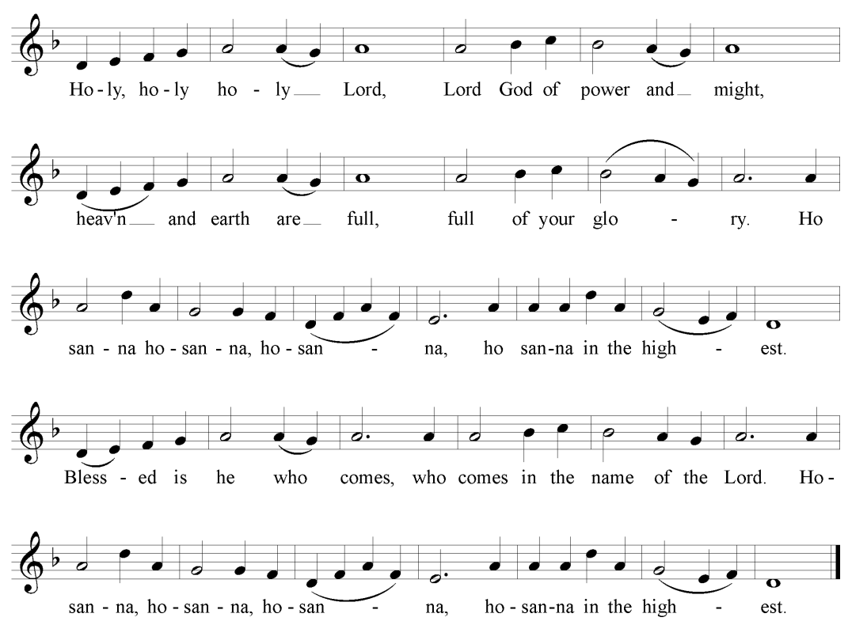
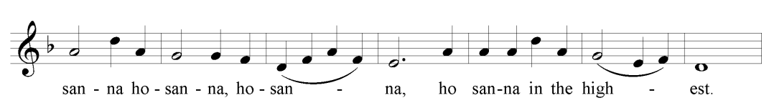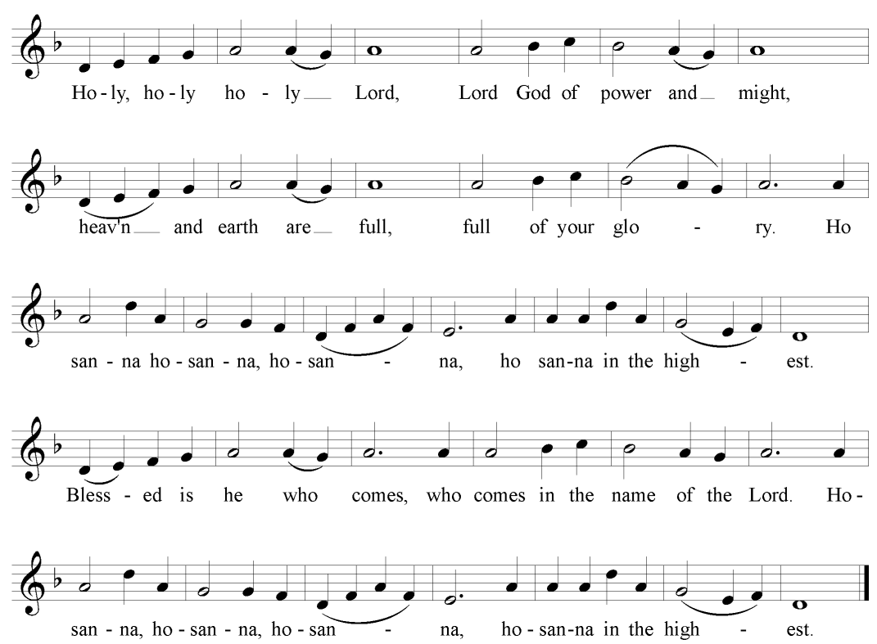

Holy and gracious God, accept our praise, through your Son our Saviour Jesus Christ; who on the night he was handed over to suffering and death, took bread and gave you thanks, saying, “Take, and eat: this is my body which is broken for you.” In the same way he took the cup, saying, “This is my blood which is shed for you. When you do this, you do it in memory of me.”

Remembering, therefore, his death and resurrection, we offer you this bread and this cup, giving thanks that you have made us worthy to stand in your presence and serve you.

We ask you to send your Holy Spirit upon the offering of your holy Church. Gather into one all who share in these sacred mysteries, filling them with the Holy Spirit and confirming their faith in the truth, that together we may praise you and give you glory through your Servant, Jesus Christ.

All glory and honour are yours, Creator and Son, with the Holy Spirit in the holy Church, now and for ever.
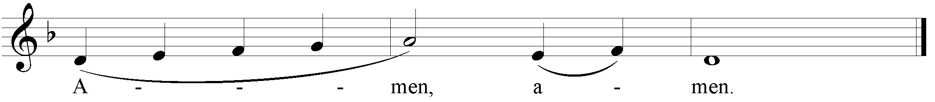

The Lord’s Prayer:
As our Saviour taught us, let us sing, 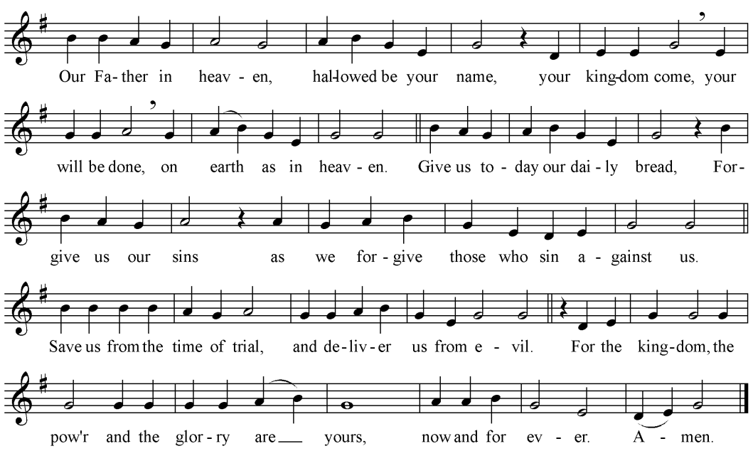
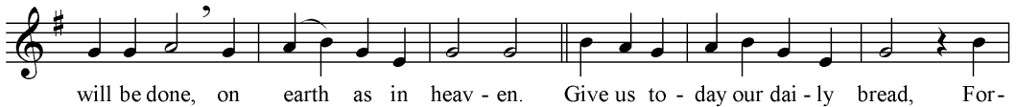
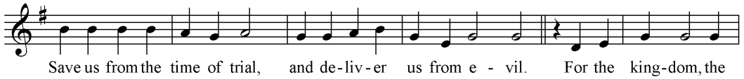
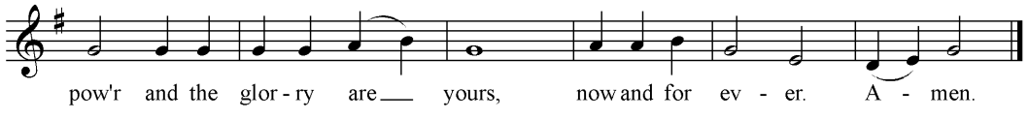

The Breaking of the Bread
We break the bread of life, and that life is the light of the world.
All: God here among us, light in the midst of us, bring us to light and life.

The Communion
The table is set, all are welcome. If you would prefer a blessing, please indicate this by crossing your arms over your chest. The bread is gluten free for all to share in the One Bread, One Body.

Agnus Dei (All sing)
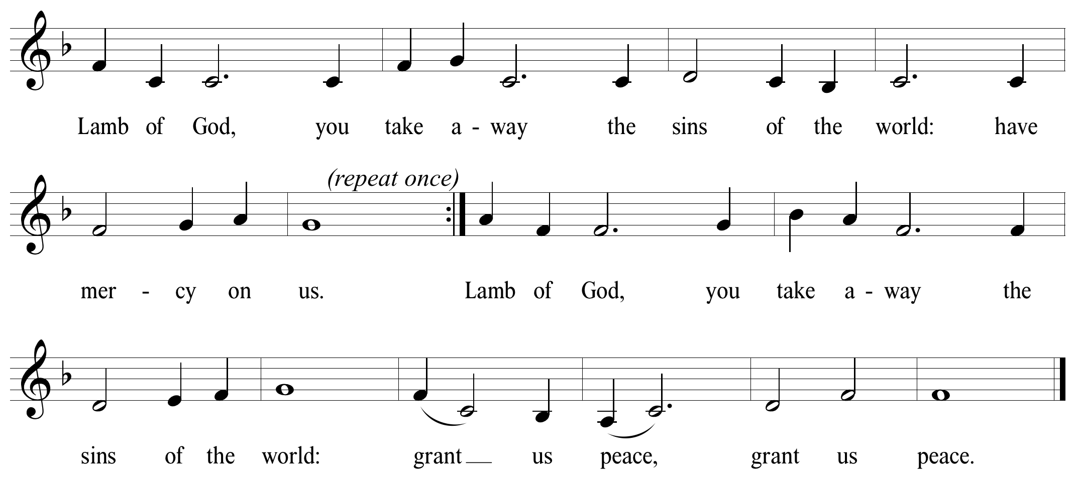
Prayer after Communion: God of all, the child born for us is the Saviour of the world. May he who made us your children welcome us into your kingdom, where he is alive and reigns with you now and for ever. Amen.

The Doxology:
All: Glory to God, whose power, working in us, can do infinitely more than we can ask or imagine. Glory to God from generation to generation, in the Church and in Christ Jesus, for ever and ever. Amen.

The Blessing
May the joy of the angels, the eagerness of the shepherds, the perseverance of the wise men, the obedience of Joseph and Mary, and the peace of the Christ-child be yours this Christmas; and the blessing of God almighty, Father, Son and Holy Spirit be among you and remain with you now and always.

Recessional Hymn #154: Joy to the World

The Dismissal
Go forth in the name of Christ.
All: Thanks be to God.

Postlude

Merry Christmas to you from all at Holy Trinity!

