HOLY TRINITY ANGLICAN CHURCH

December 24th, 2024 at 7:00PM
The Nativity of the Lord

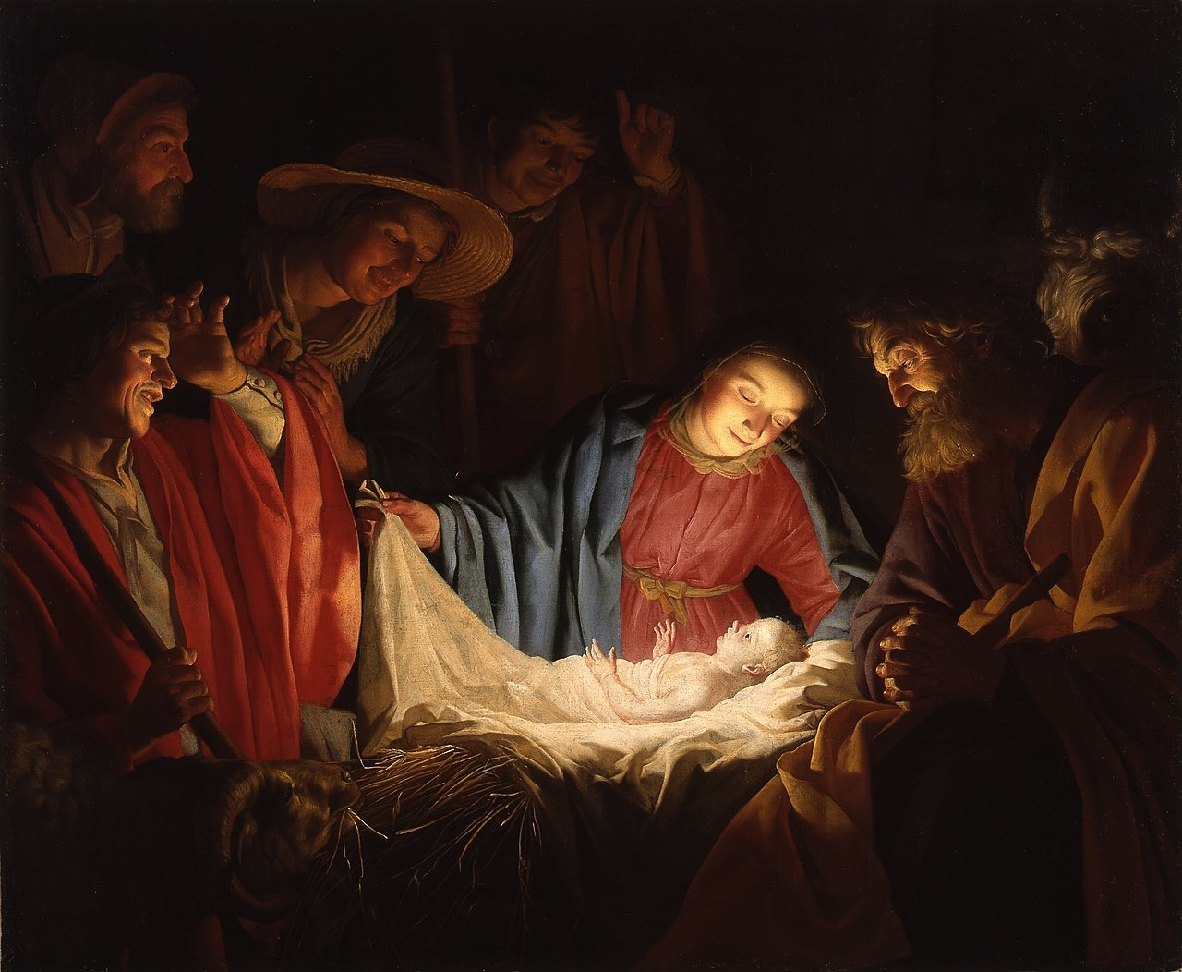
“Adoration of the Shepherds” by Gerard van Honthorst, 1622

I bring you good news of great joy which will come to all the people;
for to you is born this day a Saviour, Christ the Lord.
Luke 2:10-11

THE GATHERING OF THE COMMUNITY

Processional Hymn: O Come All Ye Faithful
1. O come, all ye faithful,  Joyful and triumphant,  O come ye, O come ye to Bethlehem;  Come and behold him  Born the king of Angels  O come let us adore him  O come let us adore him  O come let us adore him  Christ the Lord | 3. Sing, choirs of angels  Sing in exultation,  Sing, all ye citizens of heav’n above;  Glory to God  In the highest:  O come let us adore him …
2. God of God  Light of light,  Lo! he abhors not the Virgin’s womb  Very God,  Begotten, not created:  O come let us adore him … | 4. Yea, Lord we greet Thee,  Born this happy morning,  Jesus, to thee be glory giv’n:  Word of the Father,  Now in flesh appearing  O come let us adore him …

Apostolic Greeting
The grace of our Lord Jesus Christ, and the love of God, and the fellowship of the Holy Spirit, be with you all.
All: And also with you.

Gloria: Angels We Have Heard on High
1. Angels we have heard on high,
Sweetly singing o’er the plains,
And the mountains in reply,
Echoing their joyous strains
Refrain: Gloria, in excelsis Deo!
Gloria, in excelsis Deo!

Collect of the Day:
Let us pray. Eternal God, this holy night is radiant with the brilliance of your one true light. As we have known the revelation of that light on earth, bring us to see the splendour of your heavenly glory; through Jesus Christ our Lord, who is alive and reigns with you and the Holy Spirit, one God, now and for ever. Amen.
Kids Talk and Advent Wreath Lighting

Angels We Have Heard on High
2. See Him in a manger laid,
Whom the choirs of angels praise;
Mary, Joseph, lend your aid,
While our hearts in love we raise.
Refrain: Gloria, in excelsis Deo!
Gloria, in excelsis Deo

THE PROCLAMATION OF THE WORD

A reading from Isaiah 52:7-10
How beautiful upon the mountains are the feet of the messenger who announces peace, who brings good news, who announces salvation, who says to Zion, "Your God reigns." Listen! Your sentinels lift up their voices, together they sing for joy; for in plain sight they see the return of the Lord to Zion. Break forth together into singing, you ruins of Jerusalem; for the Lord has comforted his people, he has redeemed Jerusalem. The Lord has bared his holy arm before the eyes of all the nations; and all the ends of the earth shall see the salvation of our God.
The Word of the Lord
All: Thanks be to God.

Hymn: Away in a Manger
1. Away in a manger, no crib for a bed,  the little Lord Jesus lay down His sweet head, the stars in the bright sky  looked down where He lay,  the little Lord Jesus asleep on the hay. | 3. Be near me, Lord Jesus, I ask Thee to stay  close by me for ever and love me, I pray.  Bless all the dear children in Thy tender care  and fit us for heaven, to live with Thee there.
2. The cattle are lowing, the baby awakes
but little Lord Jesus, no crying He makes.
I love Thee, Lord Jesus,
look down from the sky.
And stay by my side until morning is nigh.

A reading from Hebrews 1:1-12
Long ago God spoke to our ancestors in many and various ways by the prophets, but in these last days he has spoken to us by a Son, whom he appointed heir of all things, through whom he also created the worlds. He is the reflection of God's glory and the exact imprint of God's very being, and he sustains all things by his powerful word. When he had made purification for sins, he sat down at the right hand of the Majesty on high, having become as much superior to angels as the name he has inherited is more excellent than theirs. For to which of the angels did God ever say, "You are my Son; today I have begotten you"? Or again, "I will be his Father, and he will be my Son"? And again, when he brings the firstborn into the world, he says, "Let all God's angels worship him." Of the angels he says, "He makes his angels winds, and his servants flames of fire." But of the Son he says, "Your throne, O God, is forever and ever, and the righteous scepter is the scepter of your kingdom. You have loved righteousness and hated wickedness; therefore God, your God, has anointed you with the oil of gladness beyond your companions." And, "In the beginning, Lord, you founded the earth, and the heavens are the work of your hands; they will perish, but you remain; they will all wear out like clothing; like a cloak you will roll them up, and like clothing they will be changed. But you are the same, and your years will never end."
The Word of the Lord
All: Thanks be to God.

Gospel Acclamation: 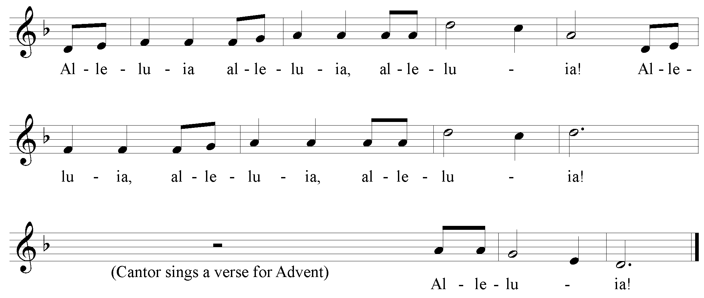
Gospel Reading
The Lord be with you.
All: And also with you.
The Holy Gospel of our Lord Jesus Christ according to Luke 2:1--20
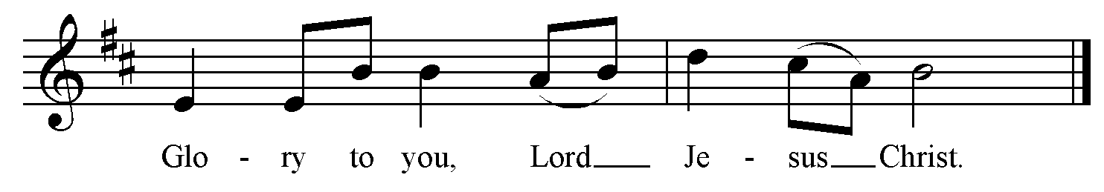
In those days a decree went out from Emperor Augustus that all the world should be registered. This was the first registration and was taken while Quirinius was governor of Syria. All went to their own towns to be registered. Joseph also went from the town of Nazareth in Galilee to Judea, to the city of David called Bethlehem, because he was descended from the house and family of David. He went to be registered with Mary, to whom he was engaged and who was expecting a child. While they were there, the time came for her to deliver her child. And she gave birth to her firstborn son and wrapped him in bands of cloth, and laid him in a manger, because there was no place for them in the inn. In that region there were shepherds living in the fields, keeping watch over their flock by night. Then an angel of the Lord stood before them, and the glory of the Lord shone around them, and they were terrified. But the angel said to them, "Do not be afraid; for see-- I am bringing you good news of great joy for all the people: to you is born this day in the city of David a Savior, who is the Messiah, the Lord. This will be a sign for you: you will find a child wrapped in bands of cloth and lying in a manger." And suddenly there was with the angel a multitude of the heavenly host, praising God and saying, "Glory to God in the highest heaven, and on earth peace among those whom he favors!" When the angels had left them and gone into heaven, the shepherds said to one another, "Let us go now to Bethlehem and see this thing that has taken place, which the Lord has made known to us." So they went with haste and found Mary and Joseph, and the child lying in the manger. When they saw this, they made known what had been told them about this child; and all who heard it were amazed at what the shepherds told them. But Mary treasured all these words and pondered them in her heart. The shepherds returned, glorifying and praising God for all they had heard and seen, as it had been told them.
The Gospel of Christ.
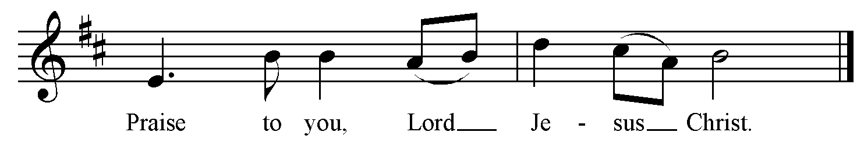

Gospel Acclamation:
The Sermon: The Rev. Danielle Key

The Apostles’ Creed:
Let us confess the faith of our baptism as we say,
I believe in God, the Father almighty, creator of heaven and earth.
I believe in Jesus Christ, his only Son, our Lord. He was conceived by the power of the Holy Spirit and born of the Virgin Mary. He suffered under Pontius Pilate, was crucified, died, and was buried. He descended to the dead. On the third day he rose again. He ascended into heaven, and is seated at the right hand of the Father. He will come again to judge the living and the dead. I believe in the Holy Spirit, the holy catholic Church, the communion of saints, the forgiveness of sins, the resurrection of the body, and the life everlasting. Amen.

The Prayers of the People
Response to each intercession:
Lord in your mercy…
All: Hear our prayer.

Confession and Absolution
Christ the light of the world has come to dispel the darkness of our hearts. Let us turn to the light and confess our sins. Most merciful God,
All: We confess that we have sinned against you in thought, word, and deed, by what we have done, and by what we have left undone. We have not loved you with our whole heart; we have not loved our neighbours as ourselves. We are truly sorry and we humbly repent. For the sake of your Son Jesus Christ, have mercy on us and forgive us, that we may delight in your will, and walk in your ways, to the glory of your name. Amen.
May God who loved the world so much that he sent his Son to be our Saviour forgive us our sins and make us holy to serve him in the world, through Jesus Christ our Lord.

The Peace
Unto us a child is born, unto us a son is given, and his name shall be called the Prince of Peace. The peace of the Lord be always with you.
All: And also with you.

THE CELEBRATION OF THE EUCHARIST

Gradual Hymn: Joy to the World
1. Joy to the world, the Lord is come! 3. He rules the world with truth and grace,
Let earth receive her King! and makes the nations prove
Let every heart prepare Him room, the glories of His righteousness
and heav'n and nature sing, and wonders of His love,
and heav'n and nature sing, and wonders of His love,
and heav'n, and heav'n and nature sing. And wonders, wonders of His Love.
2. Joy to the earth, the Savior reigns!
Let men their songs employ,
while fields and floods, rocks, hills, and plains
repeat the sounding joy,
repeat the sounding joy,
repeat, repeat the sounding joy.
Prayer over the Gifts
Source of light and gladness, accept all we offer on this joyful feast. May we grow up in him who unites our lives to yours; for he is Lord for and for ever. Amen.

Eucharistic Prayer 3
The Lord be with you.
All: And also with you.
Lift up your hearts.
All: We lift them to the Lord.
Let us give thanks to the Lord our Creator.
All: It is right to give our thanks and praise.

Blessed are you, gracious God, creator of heaven and earth; we give you thanks and praise through Jesus Christ our Lord, who in the mystery of his incarnation was made perfect man of the flesh of the Virgin Mary his mother; in him we have seen a new and radiant vision of your glory. Therefore, with all the angels of heaven, we lift our voices and sing our joyful hymn of praise to proclaim the glory of your name. 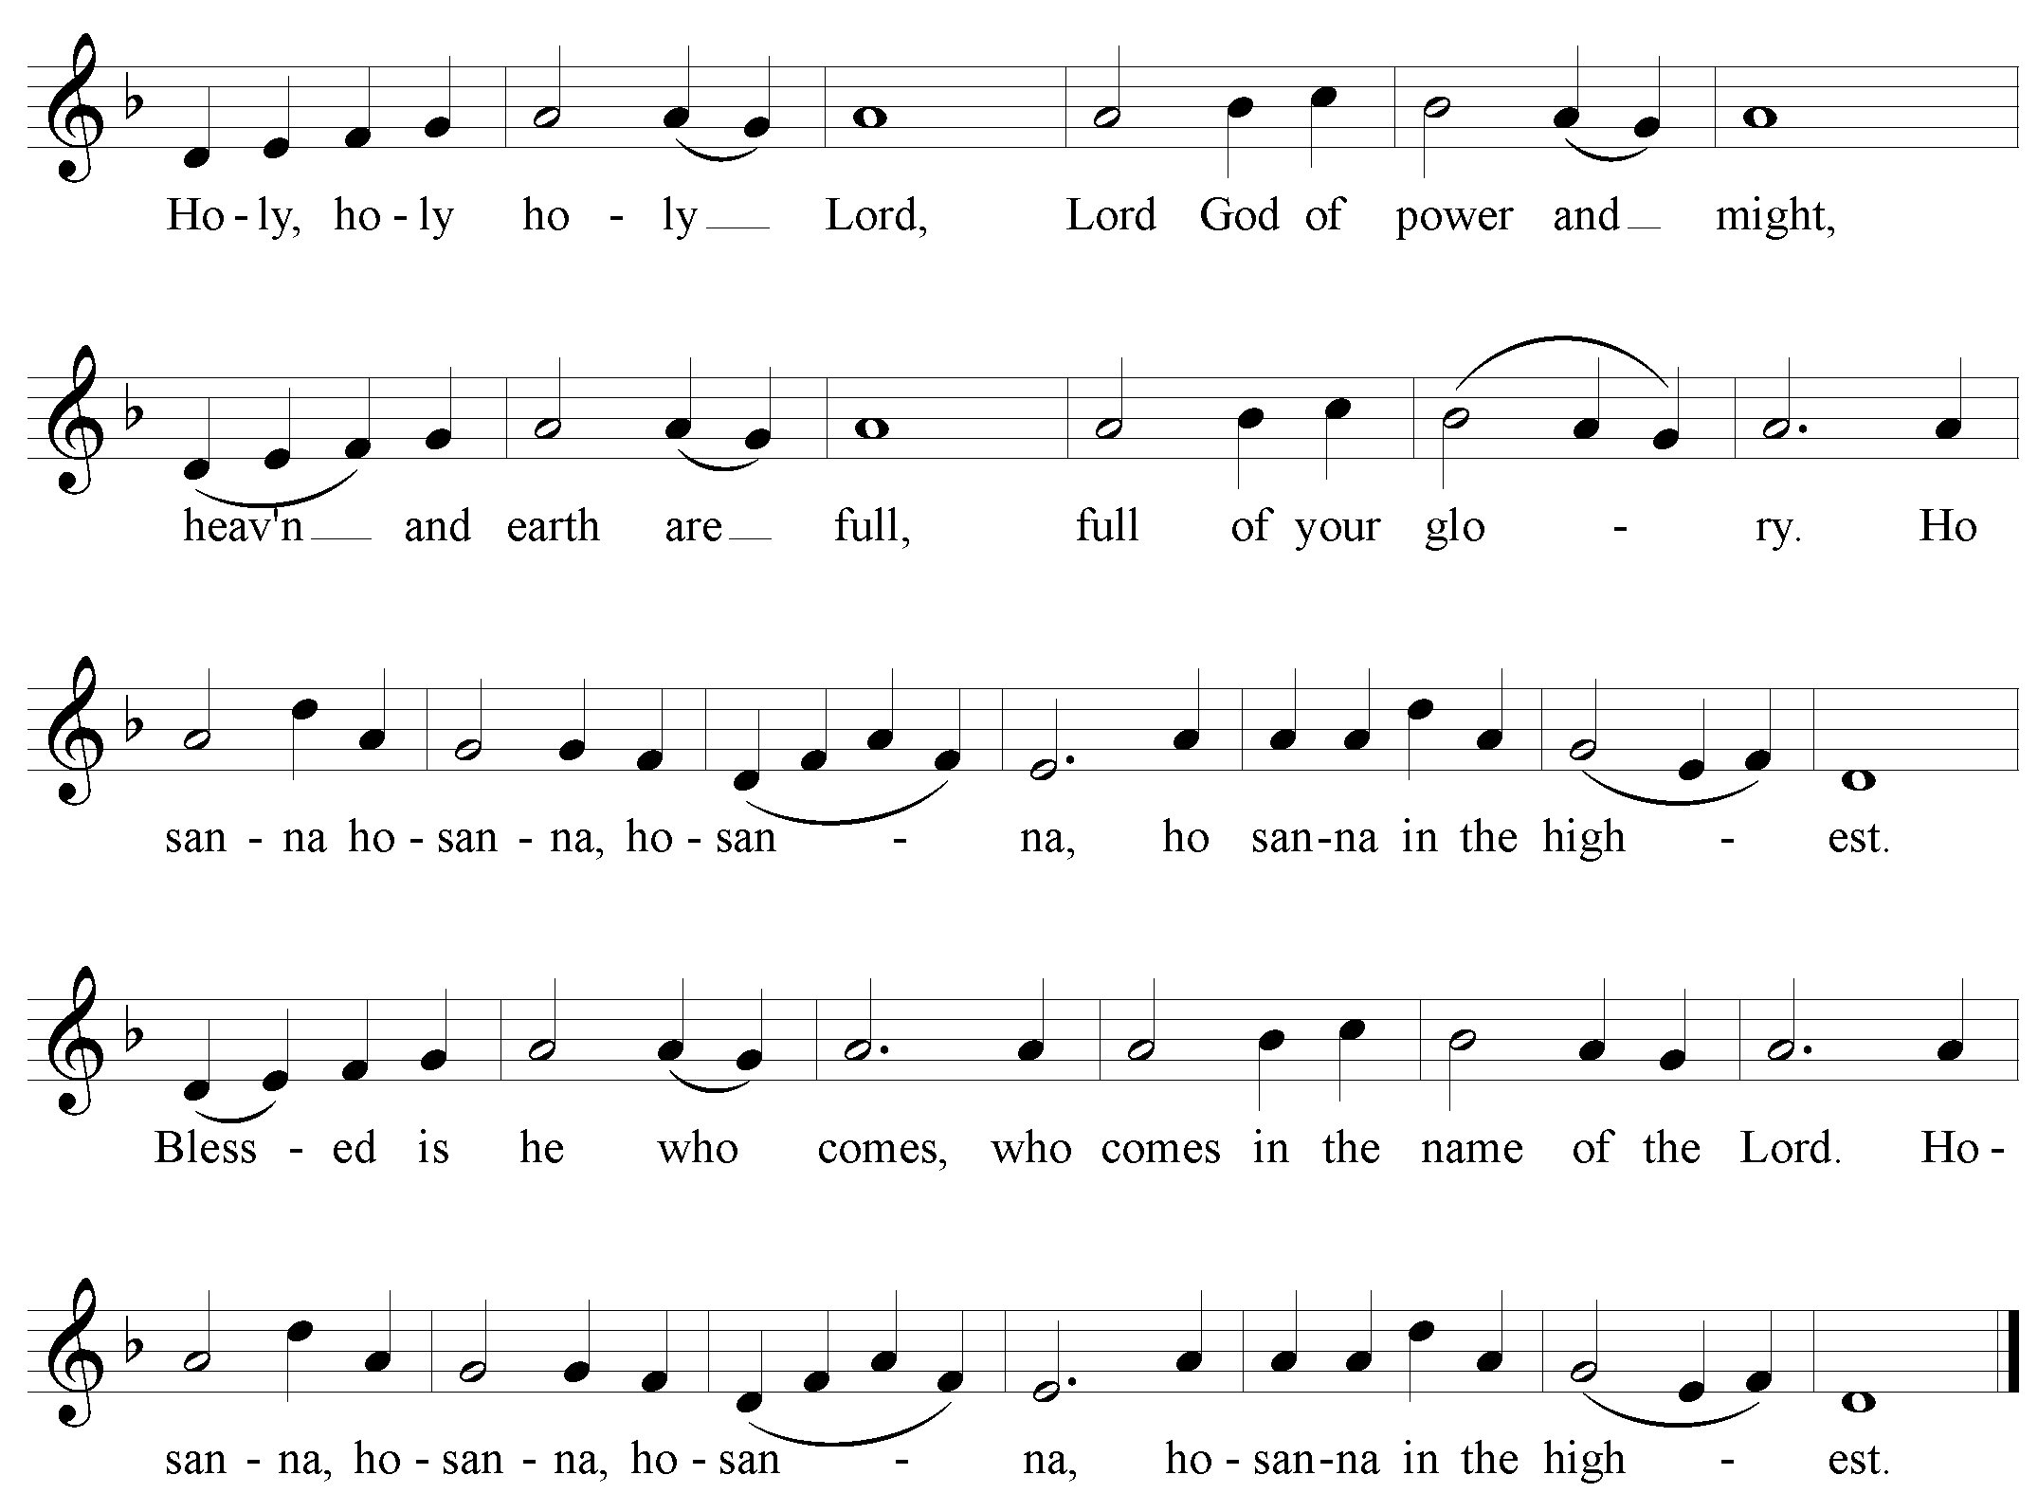
We give thanks to you, Lord our God, for the goodness and love you have made known to us in creation; in calling Israel to be your people; in your Word spoken through the prophets; and above all in the Word made flesh, Jesus your Son.

For in these last days you sent him to be incarnate from the Virgin Mary, to be the Saviour and Redeemer of the world. In him, you have delivered us from evil, and made us worthy to stand before you. In him, you have brought us out of error into truth, out of sin into righteousness, out of death into life.

On the night he was handed over to suffering and death, a death he freely accepted, our Lord Jesus Christ took bread; and when he had given thanks to you, he broke it, and gave it to his disciples, and said, “Take, eat: this is my body which is given for you. Do this for the remembrance of me.”

After supper he took the cup of wine; and when he had given thanks, he gave it to them, and said, “Drink this, all of you: this is my blood of the new covenant, which is shed for you and for many for the forgiveness of sins. Whenever you drink it, do this for the remembrance of me.” Therefore, Father, according to his command,
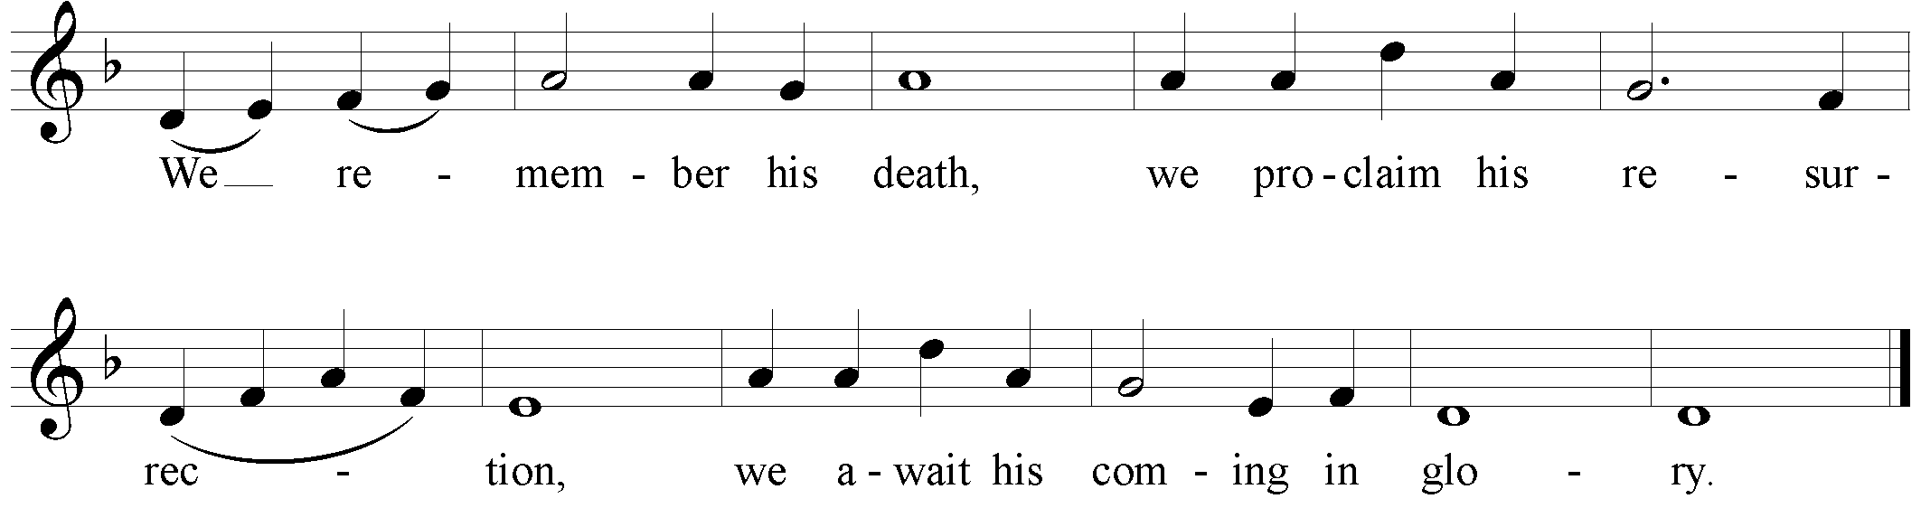
and we offer our sacrifice of praise and thanksgiving to you, Lord of all; presenting to you, from your creation, this bread and this wine. We pray you, gracious God, to send your Holy Spirit upon these gifts, that they may be the sacrament of the body of Christ and his blood of the new covenant. Unite us to your Son in his sacrifice, that we, made acceptable in him, may be sanctified by the Holy Spirit.

In the fullness of time, reconcile all things in Christ, and make them new, and bring us to that city of light where you dwell with all your sons and daughters; through Jesus Christ our Lord, the firstborn of all creation, the head of the Church, and the author of our salvation; by whom, and with whom, and in whom, in the unity of the Holy Spirit, all honour and glory are yours, almighty Father, now and forever. 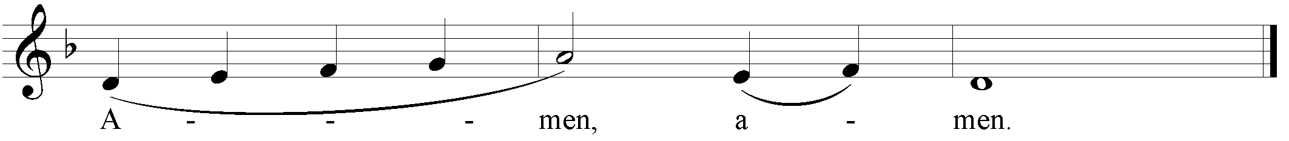
The Lord’s Prayer:
As our Saviour taught us, let us sing:
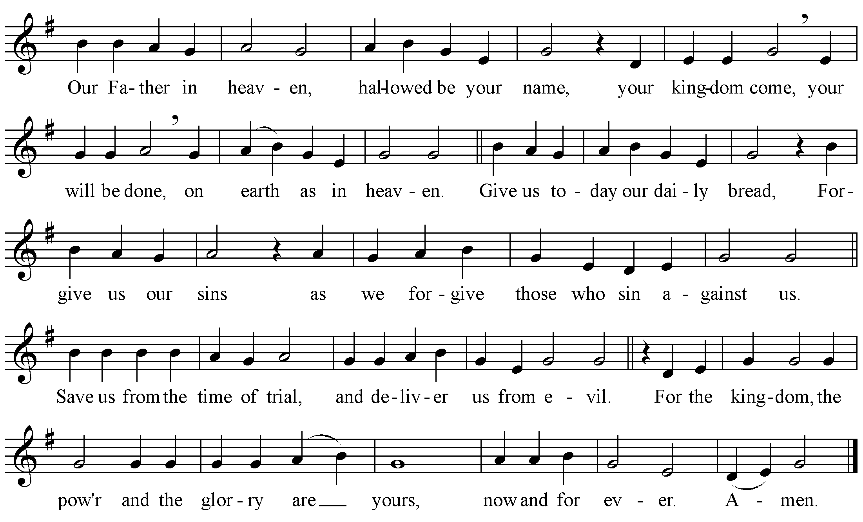
The Breaking of the Bread
We break the bread of life, and that life is the light of the world.
All: God here among us, light in the midst of us, bring us to light and life.

The gifts of God for the People of God.
All: Thanks be to God.

Agnus Dei

The Communion
The table is set, all are welcome. If you would prefer a blessing, please indicate this by crossing your arms over your chest. The bread is gluten free for all to share in the One Bread, One Body.

Prayer after Communion:
God of all, tonight you have united earth and heaven in sending your Son to take our human nature. May we who have tasted heavenly things share in the life of his eternal kingdom. We ask this in the name of Jesus Christ our Lord. Amen.

The Doxology:
Glory to God,
All: whose power, working in us, can do infinitely more than we can ask or imagine. Glory to God from generation to generation, in the Church and in Christ Jesus, for ever and ever. Amen.

The Blessing
May Christ, who by his Incarnation gathered into one, things earthly and heavenly, fill you with his joy and peace; and the blessing of God Almighty, the Creator, the Son, and the Holy Spirit, be among you, and remain with you always. Amen.

Closing Hymn: Silent Night
1. Silent night! holy night!  All is calm, all is bright.  Round yon virgin mother and child.  Holy infant so tender and mild,  Sleep in heavenly peace,  Sleep in heavenly peace! | 3. Silent night! holy night!  Son of God, love’s pure light  Radiant beams from thy holy face,  With the dawn of redeeming grace,  Jesus, Lord, at thy birth.  Jesus, Lord, at thy birth!
2. Silent night! holy night!
Shepherds quake at the sight:
Glories stream from heaven afar,
Heavenly hosts sing Alleluia,
Christ, the Saviour, is born!
Christ, the Saviour, is born!

The Dismissal
Go forth into the worth rejoicing in the birth of the newborn King.
All: Thanks be to God.

Postlude

Merry Christmas from all of us at Holy Trinity!
God’s blessing and love to you all!

